
Medford City Council
The Thirty-Seventh Regular Meeting

Medford, Massachusetts
December 11, 2007

City Council
President Robert A. Maiocco
Vice President Breanna Lungo
Stephanie Muccini Burke
Paul A. Camuso

Frederick N. Dello Russo, Jr.
Michael J. Marks
Robert M. Penta

Council President Robert A. Maiocco called the Thirty-Seventh Meeting of the Medford
City Council at 7:00 P.M. at the Howard F. Alden Memorial Auditorium, Medford
City Hall.
ROLL CALL

SALUTE TO THE FLAG

RECORDS

The Records of the meeting of December 4, 2007 were passed to Councillor Camuso

HEARINGS

07-677

TAX HEARING

NOTICE OF PUBLIC HEARING
CITY OF MEDFORD

A Public Hearing will be held by the Medford City Council in the Howard F. Alden Memorial Chambers, City Hall, Medford, MA., on Tuesday, December 11, 2007 at 7:00 P.M.

The purpose of the hearing is to hear the Board of Assessors on the following items for the purpose of allocation of the FY 2008 Property Tax.

- To determine the residential factor to be used for FY 2008
- Select an open space discount
- Select a residential exemption
- Select a small commercial exemption

07-677 (CONT)
Call 781-393-2501 for any aids/accommodations. T.D.D. 781-393-2516. The City of Medford is an EEO/AA/504 Employer.

By Order of the Medford City Council

S/Edward P. Finn, City Clerk

07-683
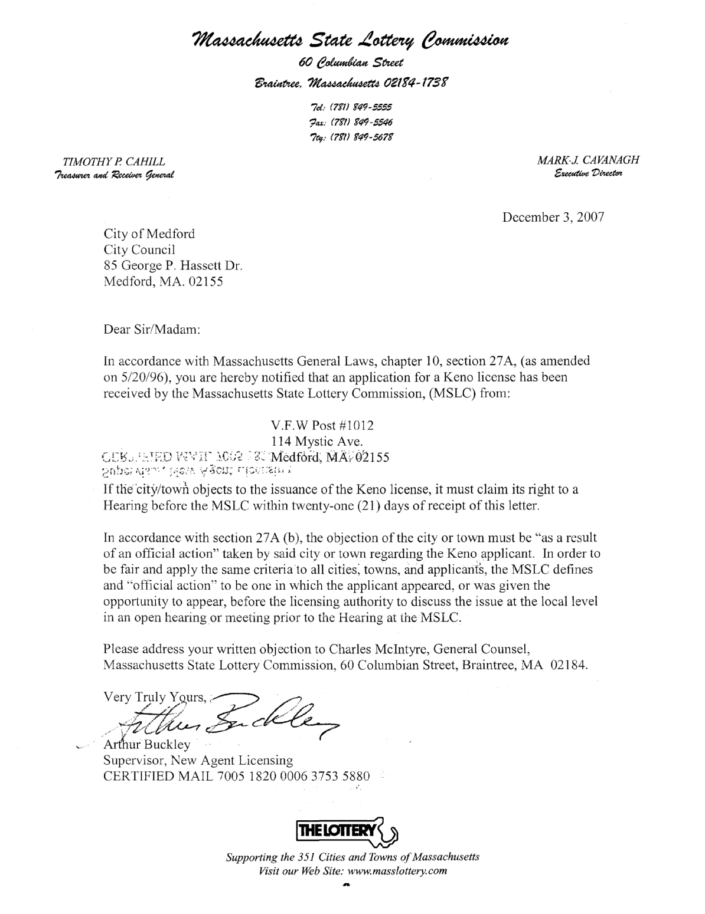

MOTIONS, ORDERS AND RESOLUTIONS

07-684-Offered by Councillor Burke
Whereas, the Commonwealth of Massachusetts established the Massachusetts Water pollution Abatement Trust,
Whereas, both a Clean Water Program and a Drinking Water Program exists with a maximum interest rate of 2%,
Be it resolved, that the auditor inform this body if the City of Medford has ever applied for funding and further, that the City consider applying for potential infrastructure improvements from faulty sewer outflows that will curb water pollution in the next round of funding

UNFINISHED BUSINESS

Upon motion of _________________, all Unfinished Business on the Table was taken from the table for action.

  - Council endorse letter to State Delegation re; Tax Abatement for Disabled

IN COUNCIL OCTOBER 24, 2006 TABLED

IN COUNCIL OCTOBER 23, 2007 TABLED

07-332- Mausoleum at Oak Grove Cemetery

IN COUNCIL MAY 1, 2007 TABLED

06-009 Sub Committee on Rules Meeting Report

IN COUNCIL DECEMBER 4, 2007 SECTION 22

  - City Council Expense Increase

IN COUNCIL DECEMBER 4, 2007 TABLED

Public Participation

COUNCIL PAPERS IN COMMITTEE

Reports Due/ Deadlines
05-895- Comprehensive Master Wellington Plan-3 months-Jan. 17, 2006
07-072-Intercept Program
07-484-SPC Extended Hours Pranzi’s, Winthrop St. 3 month Review December 4, 2007

Records:

The Records of the meeting of December 4, 2007 were passed to Councillor Camuso

Adjournment:

